Meeting to be held on Tuesday, 17th January 2023
at 7.30pm in the Committee Room, Wesham Community Centre.

AGENDA

APOLOGIES:

CODE OF CONDUCT AND STANDING ORDERS
Members are reminded of the standard of conduct they must adhere to during Town Council meetings.

DECLARATION OF INTERESTS:
Members are reminded that any direct or indirect pecuniary or other interests should be declared as required by the Council’s Code of Conduct for Members.

23/001 APPROVAL OF THE MINUTES OF THE COUNCIL MEETING HELD
20th December 2022
Future format for minutes

23/002 MATTERS ARISING – any item not covered by agenda or action list

Mayor for 2023–24 ?

23/003 POLICING ISSUES
- Crime Reports – police.org.uk website > area > PR4 3DR (WCC postcode)
- Policing Issues – to discuss any items raised by Councillors

Guest appearance by PCSO 7658 Anna Morris

23/004 PLANNING -
- Planning Applications - FBC updating Planning system issues

22/0760 – Storage building @ Mowbreck Caravan Park
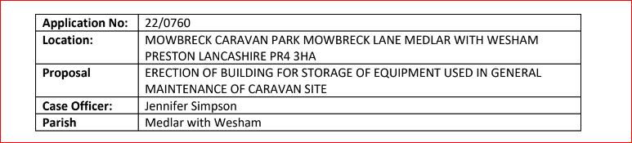

23/0014 – Single Storey Agricultural worker dwelling on Weeton Road
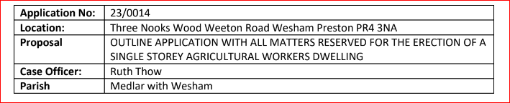

- Meeting on 22/11/2022 with Andrew Stell re Mill Farm applications inlcuding 22/0616, 20/0135 & 21/0984

WTC Reply to FBC Planning
(meeting on 12th January 2023 to discuss & draft response)

- Planning training (NALC) for Wesham councillors

23/005 PLAYING FIELDS and OPEN SPACES
- Open Spaces Contract - to discuss any issues raised by Councillors

- Review of Grounds Maintenance
  - Winter Work quotation – Robert Pickervance
- SLA for Grounds Maintenance Tender 01/04/2023 – 31/03/2026
- Bowling Green Tender 01/04/2023 – 31/03/2026 from Tom Ascroft

- Fleetwood Road Playing Fields - to discussed any issues raised

Ratification of Pavilion Plumbing repairs

- Doorstep Green, Derby Road - to discussed any issues raised.

- Allotments – ratification of 2024-25 annual fee @£35.00

23/006 HIGHWAYS AND RAILWAYS –
Traffic Incident in Wesham – Cllr L Walker
New Bus Route in Wesham – Cllr L Bickerstaffe

23/007 GOVERNANCE, FINANCE AND INSURANCE

Accounts payable and income received report –

Finance Mtg papers – Dec 2022

Accident and Incident Reporting - none

23/008 EVENTS - nothing to discuss at this January 2023 meeting
23/009 HUMAN RESOURCES
    - HR sub Committee
23/010 WESHAM COMMUNITY CENTRE
- New Tills
- Sum Up
- Pat Testing
- EA visit from FBC appointed inspector on 13th Jan 2023
- Ratification of heating system repairs

23/011 OTHER ITEMS
- Web site
- Action List – update on any items not covered by agenda

Additional items -

DATE OF NEXT MEETINGS: –
21st February 2023
21st March 2023

WTC Additional Meetings
Date | meeting
10th January | Estimates/Finance
12th January | Mill Farm Planning response
17th January | WTC monthly meeting - JAN
19th January | KJFC
24th January | SLA Grounds Maintenance review
26th January | Bowling Green SLA
31st January
7th February | WCC meeting
9th February
14th February | 2nd(Final) Estimates meeting
16th February
21st February | WTC Month meeting - FEB
23rd February
27th February

Inspection of the Allotments - (to be arranged)

Angela Hunter Date: 11th January 2023

